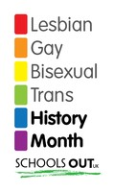
EASIER

HARDER
1. Do you think that your actions were fair? Why / Why not?
2. What rights did you take away from those with brown eyes?
3. What special privileges were you giving those with blue eyes?
4. What evidence did you have to make the statement about brown-eyed pupils being less clever than blue-eyed pupils?
5. Do you think that prejudice is normally based on evidence?
6. Can you think of any examples where prejudice happens?
7. What did this tell you about prejudice? Why do you think prejudice happens?
8. If we can “create” prejudice this easily- can we “destroy” it just as easily?
9. What can we do about prejudice?
10. What actions can we take as individuals, in our day-to-day lives?

